
Maryland Food Insecurity Map - Navigation Guide
The Maryland Food Insecurity Map can help you learn more about food insecurity and resources across Maryland. This is a detailed guide to help users understand how to use the map.
1. Default User Profiles
2. Legend, Map Layers Key, Basemap Gallery
3. Map Layers
Set Filter
Calculate Statistics
Add to Table
4. Search Engine
5. Default Map Views
Food Access
Policy and Research
6. Info Boxes
7. Visualize Data by Jurisdiction
8. Interactive Data Panel
9. Panel Toolbar
10. Selecting a Row
11. Need more assistance?

General Navigation

Default User Profiles
To improve navigation for specific needs, there are two default user profiles to choose from at the top of the page. One shows map layers specific to food assistance and the other shows map layers tailored for policy and research.
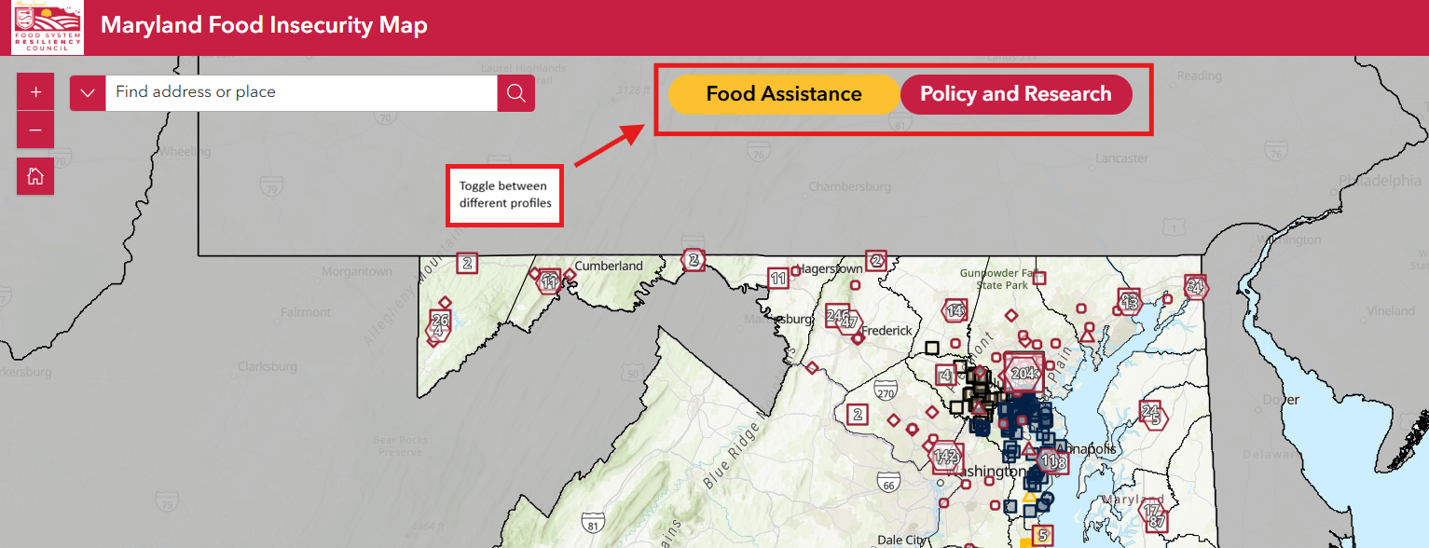

Legend, Map Layers Key, Basemap Gallery
Use the three icons on the top right of the page to toggle between the legend, map layers key, and basemap gallery. These tools can help you understand map symbols, view available data layers, and switch the underlying map style.
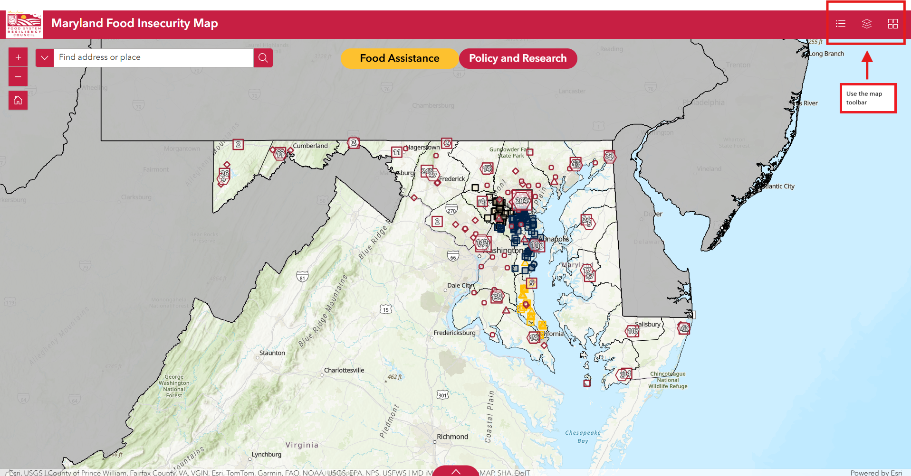

Map Layers
Layers can be turned on and off using the ‘eye’ icon on the left side of the map layers key. There are sub-layers that can be displayed allowing users to filter for a subset of the data. Multiple layers can be viewed at the same time.
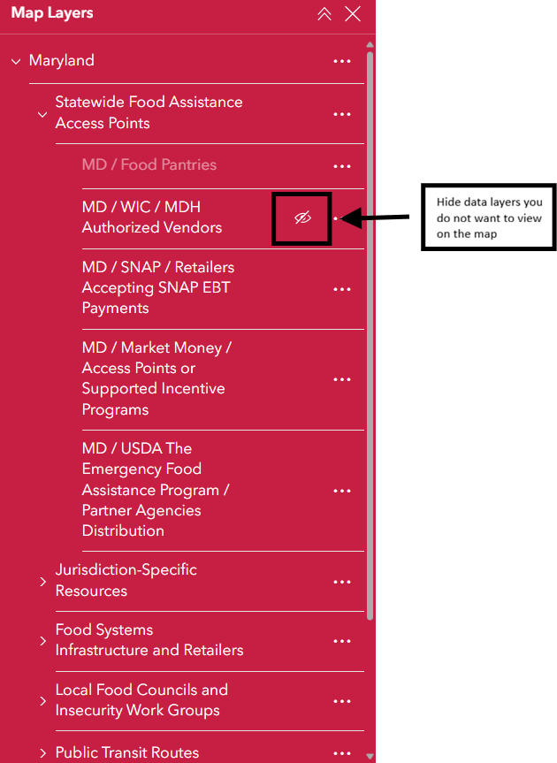
Clicking on the 3 dots next to each data layer will allow you to perform 3 different actions:
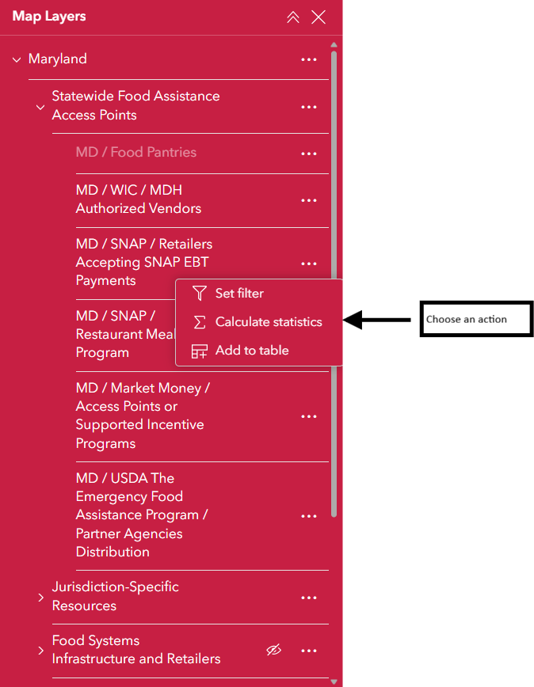

Set Filter
Filter map data by clicking ‘add’ then setting clauses or clause sets. Data can be filtered by type and relational operator.
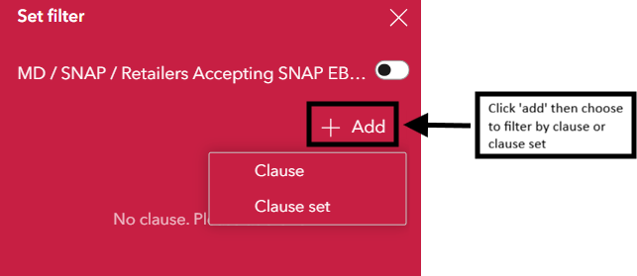

Calculate Statistics
Select a field to receive statistical information containing the number of values in a dataset, sum of values, minimum, maximum, average, and standard deviation.
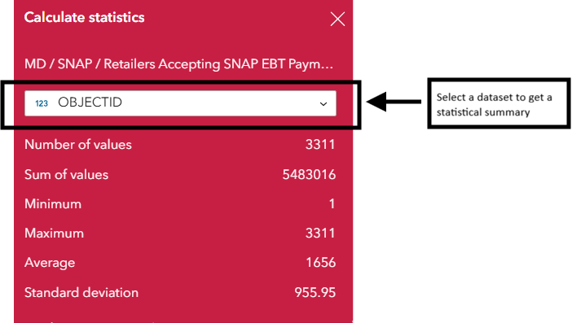

Add to Table
Add the selected data layer to the interactive data panel to visualize all attributes of a dataset. Data layers can be added to the table even when not visible on the map. Note: group headings cannot be added to the data panel.
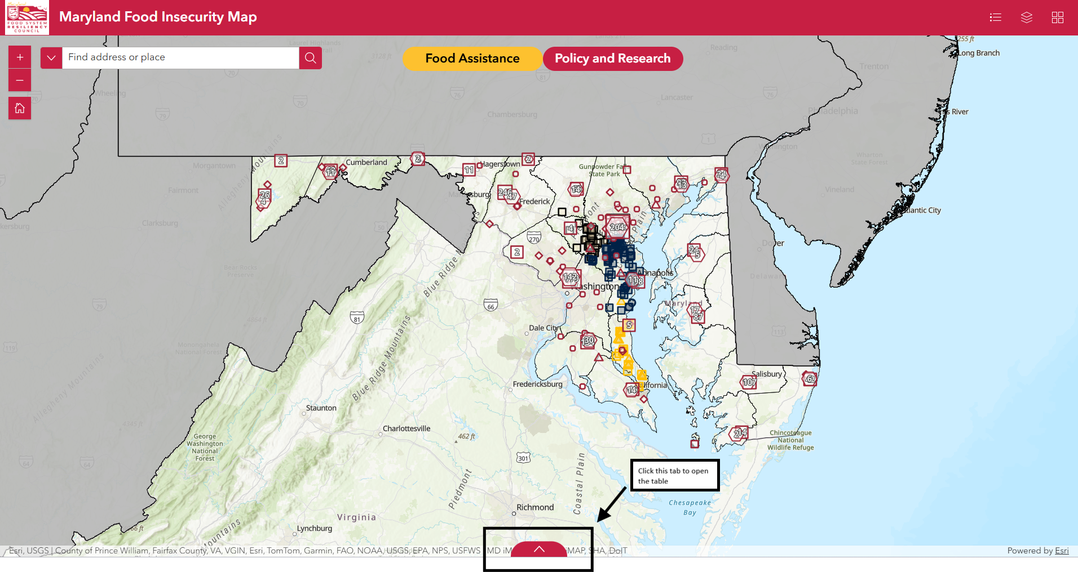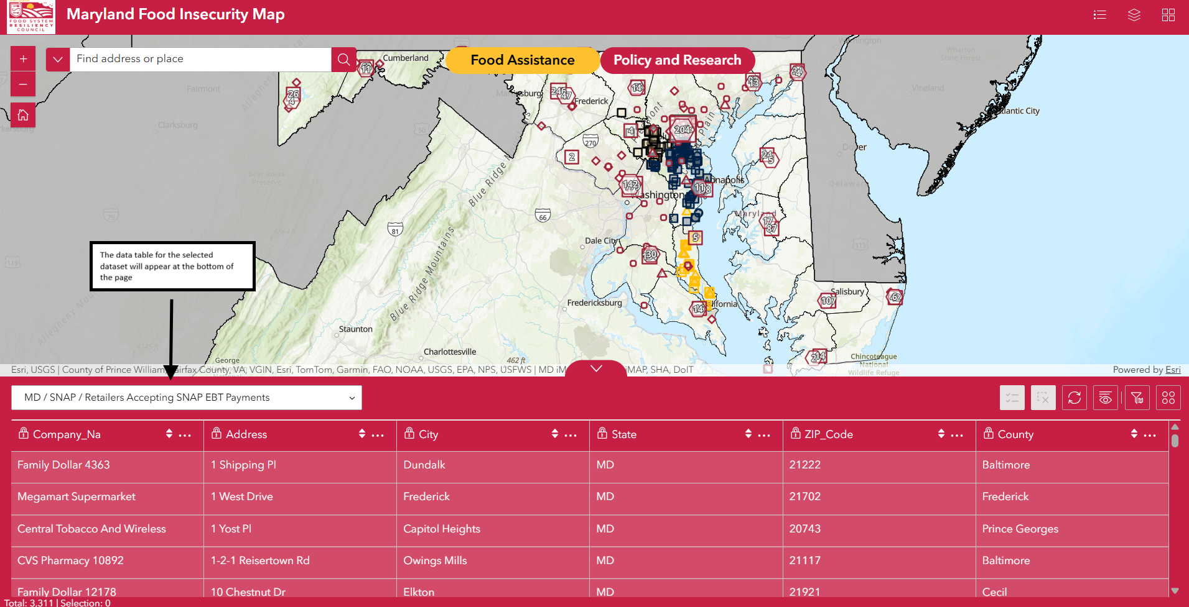

Search Engine
Use the search box at the top left of the page to browse information using a specific address or the name of a place. With this feature, you can quickly pull up information for a specific area or organization. By clicking on the caret to the left of the search box you can filter results by MD Multirole Locator or ArcGIS World Geocoding Service. The search results are also separated by these datasources.
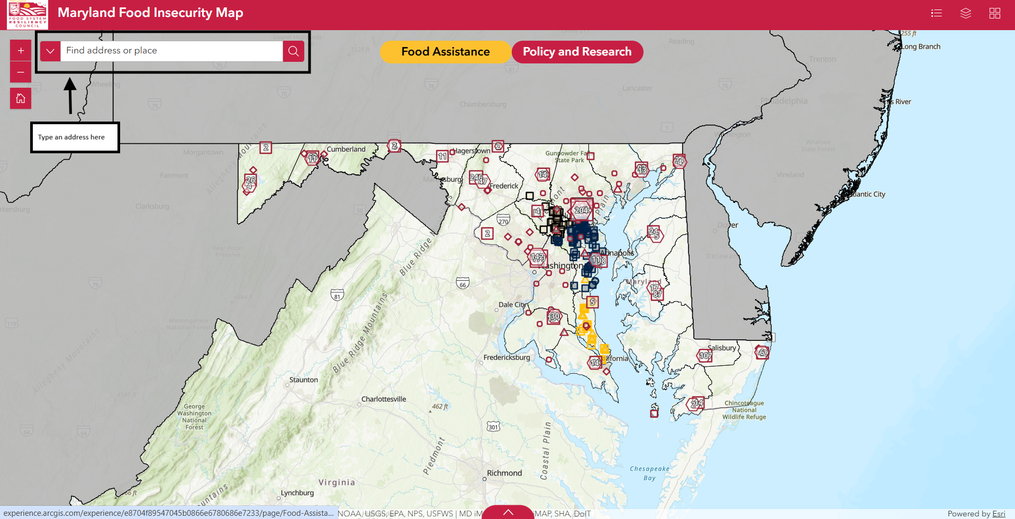
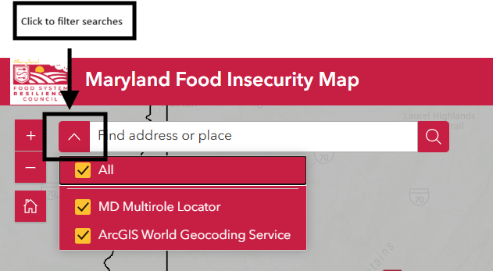

Default Map Views

Food Access
The shapes on the map represent different types of food assistance and healthy food retail access points. The size of each shape corresponds to the number of access points in a specific area with larger shapes indicating a greater number of points. The number of access points within a cluster will also be visible. Use the legend to confirm the type and size of the shapes of the map match the dataset.
The visible default map layers in this profile are Maryland county boundaries, statewide food assistance access points, and jurisdiction-specific resources. Layers can be added or removed from either profile.

Policy and Research
The colored lines on the map visualize the areas served by local food councils and food insecurity work groups. The shaded areas indicate the overall food insecurity rate within each jurisdiction with darker shading representing higher rates of food insecurity.
The visible default map layers in this profile are Maryland county boundaries, local food councils and insecurity workgroups, and Feeding America Map the Meal Gap 2025 socioeconomic and food security indicators.

Info Boxes
You can learn more about a data point or area by clicking on it, which will open a pop-up info box. Depending on which profile you have selected, different information will be shown. Clicking on clusters will reveal a cluster summary describing how many features the cluster contains. You can view other pop-up boxes for nearby features or features within a cluster by using the arrows in the top or bottom left of the pop-up. The other pop-up boxes can also be browsed or accessed by clicking on the ‘Select Feature’ or ‘Browse Features’ buttons.
From the pop-up box you can also use the ‘actions’ button (4 circles) to view the data in table, add a marker to the map, or export data depending on the data point selected.
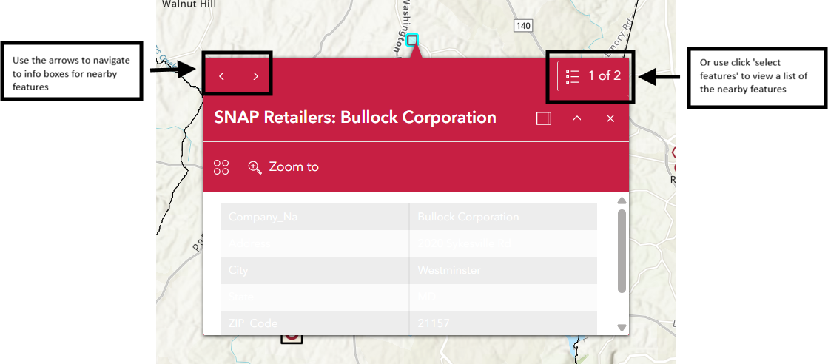
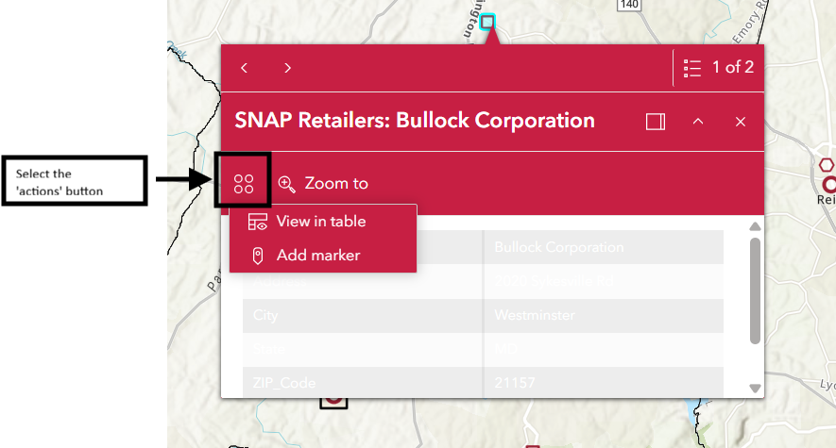

Data Access

Visualize Data by Jurisdiction
You can visualize food access resources or other items of interest by state or district. The map contains data from Maryland, Virginia, and D.C. You may also wish to activate specific socioeconomic and food security indicators by clicking the appropriate ‘eye’ icon to make these data points visible.

Interactive Data Panel
You can use the map to work with the data and answer specific research questions. Click the tab located at the bottom of the page to open an interactive data table containing geographic and business information for specific datasets.
The dropdown menu allows you to select which data you would like to view in the interactive chart. The dropdown options will change depending on which map layers you have selected. Some of the datasets are maintained by MDEM but some are maintained by other organizations so the information available may vary depending on the source.
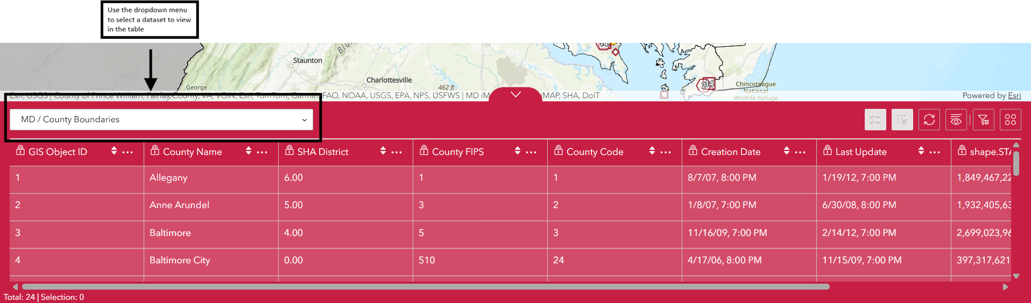
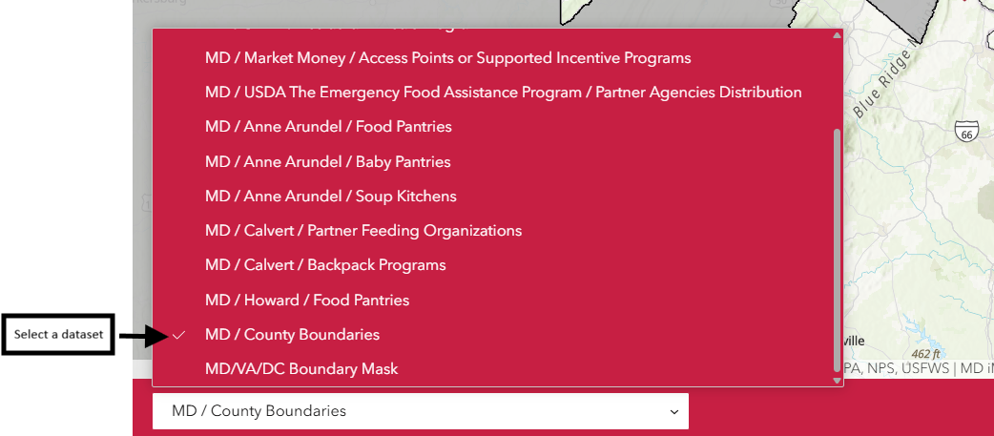

Panel Toolbar
The toolbar allows you to refresh the table, choose columns to be shown or hidden, filter data by map extent, and perform various actions. Clicking on the ‘Actions’ button will pull up a list of 4 operations that can be performed. You can filter data using clauses, calculate statistics, zoom to an area, or pan to different regions on the map.
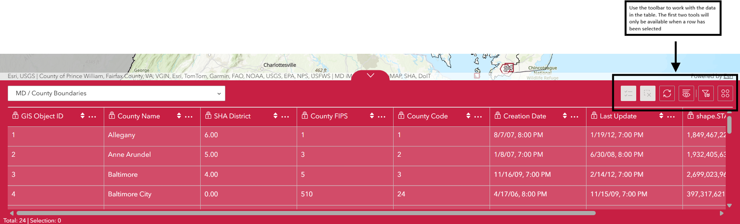
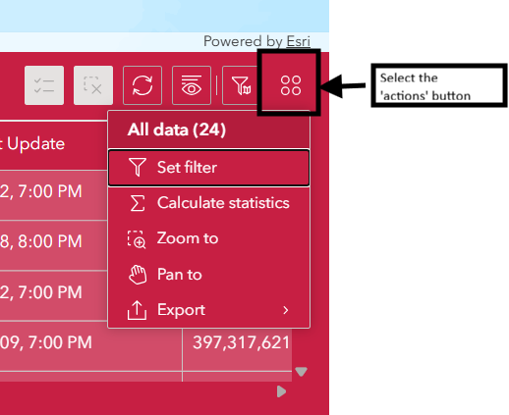

Selecting a Row
Selecting a specific row of data from a dataset, allows you to perform more actions. In addition to the above actions you can also show the selected datapoint on the map, view the datapoint in the table, pull up the information pop-up box, and add a marker on the map. The selected areas or places will glow on the map.
Selecting a row will also allow you to use the first two buttons in the toolbar on the upper right side of the panel to show the selection in its own table or clear the selection.
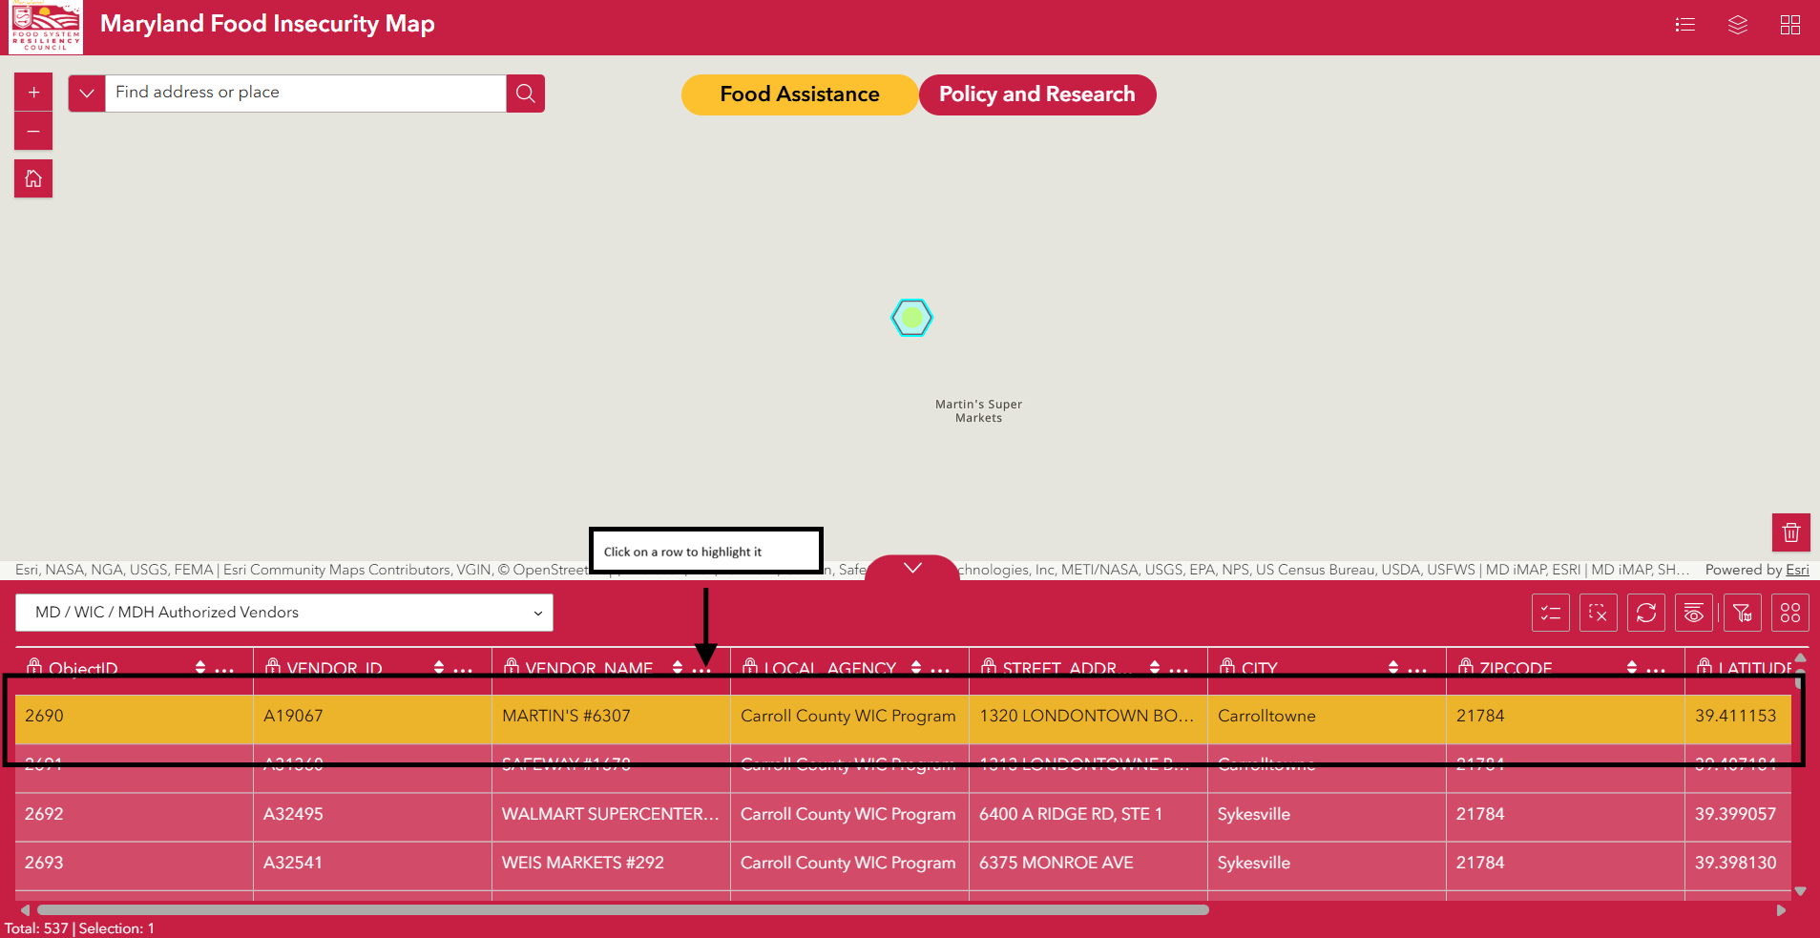
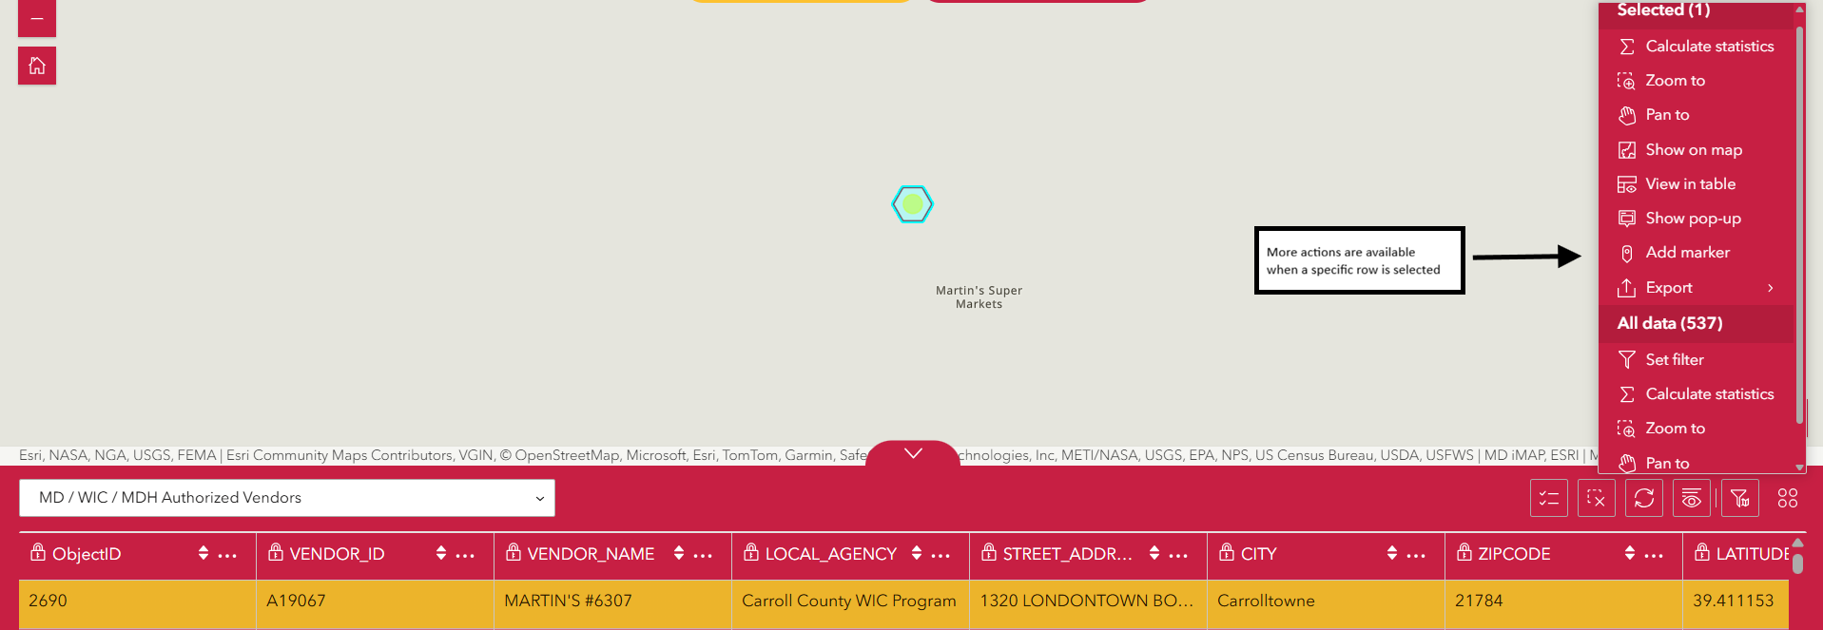

Need more assistance?
- Email mdfsrc.mdem@maryland.gov with questions or comments.
- Visit https://mdem.maryland.gov/Pages/food-resilience.aspx to access the map tutorial video (see Maryland Food Insecurity Map tab).

