**RECOMMENDED TALKING POINTS for LOCAL JURISDICTIONS**

**Know Your Zone Campaign Launch**

**14 June, 2018**

**Topic:** Know Your Zone Hurricane Evacuation Awareness Campaign

**Audience:** Maryland Residents

**Documents:** 1. Talking points

**TOPLINE TALKING POINTS**

* **What's going on:** The State of Maryland, under the leadership of the Maryland Emergency Management Agency and local Emergency Management Directors, is kicking off Maryland’s Know Your Zone campaign. The goal of this campaign is **for every Marylander to know which hurricane evacuation zone they live, work, or travel through.** By knowing your zone, as a Marylander or a visitor to our State, you will be able to quickly and safely evacuate an area that could experience flooding caused by a hurricane.
* **Know Your Zone Talking Points**
  + Residents should go to [www.KnowYourZoneMD.com](http://www.knowyourzonemd.com/) to find out the hurricane evacuation zones in their area. You could be outside of the evacuation zones, or be in Zone A, B, or C. We have developed a GIS application—simply plug in an address to find out your zone and map of your area.
  + This website will also include a hurricane preparedness guide, which includes tips and information.
  + **Communicate**—let your friends, family, and neighbors know about the importance of this initiative and that they should know about the areas in which they live and work.
  + We will be working closely with our local government partners on other methods for ensuring that every Marylander will ***“Know Your Zone.”***
* **Hurricane Information and Preparedness Background:**
  + The Atlantic Hurricane season began on June 1st and will run through November.
  + We have already seen a named subtropical storm this year: “Alberto.”
  + Imagine if Alberto’s path was different and it hit Maryland. The effects could be devastating and cause severe flooding, and multiple days of heavy rain.
  + The 2017 Hurricane Season challenged our country in ways no one predicted.
  + Harvey, Irma, and Maria were destructive storms. Although, very different, they all caused havoc and destruction: heavy flooding, wind damage, and storm surges across Texas, the Gulf Coast, Florida, and the Caribbean.
  + Since that time, Maryland has conducted hurricane evacuation studies across the State with the U.S. Army Corps of Engineers and local governments.
  + From this study, we now know the specific areas in Maryland that are most at risk of flooding caused by a hurricane coming up the coast.
  + We have labeled these areas by specific zones so that if evacuations are necessary, we can inform people which specific zones should evacuate.
  + It is important that everyone who lives, works, or visits these areas know the zones in their area.
  + Everyone in Maryland needs to take action today to prepare.
  + It only takes one storm to change your life.
    - For 2018, NOAA forecasters predict:
      * a 35 percent chance of an above-normal season
      * a 40 percent chance of a near-normal season, and
      * a 25 percent chance of a below-normal season.
      * **That’s a 75% chance that this season will be as severe or worse than last year’s**

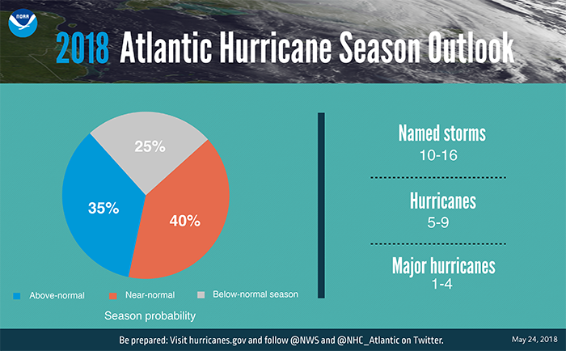

* + In Maryland, there are four main threats that hurricanes bring, which are:
    - Storm surge
    - Flooding rains
    - Hazardous wind
    - Tornadoes
  + Know what you can do to keep yourself and family safe. Before a storm, residents can:
    - Prepare an emergency kit and create a family communications plan.
    - Familiarize yourself with hurricane evacuation routes in your area and how to find higher ground.
    - Keep devices charged so that, in the event of a power outage, you can follow news and weather information for several hours.
    - During a storm, always fall back on common sense:
    - Stay tuned to radio and TV stations for official weather information.
    - Follow instructions and advice given by emergency officials.
    - When it is safe to do so, check on the safety family, friends and neighbors.
    - Stay indoors during the hurricane and away from windows and glass doors.
* **ADDITIONAL QUESTIONS AND ANSWERS:** 
  + **Q:** Are you really expecting 1 to 2 hurricanes to hit Maryland this season?
  + **A:** We can’t predict with 100% certainty whether a hurricane will hit Maryland this season. What we can do as citizens is to be prepared and organized in the event that a hurricane does make landfall near Maryland, or in the event that a major storm is expected to cause floods, cause wind damage and/or endanger life and property. It only takes one hurricane to devastate a community.
    - **KNOW:** Your Evacuation Zone
    - **HAVE:** What you need to deal with an emergency
    - **ACT:** Be familiar with evacuation areas, evacuate when ordered to do so

What I can tell you though, is that since we have been tracking Atlantic storms, we have seen an increase in the average number of named storms, hurricanes and major hurricanes, particularly since 2000.